

Arab American University
Faculty of Information Technology
Computer Science Department
Artificial Intelligence

Arabic Letters Sign Language Recognition
(Letters)

Project Team: Layan Diab, Yazan Alayadi, Sara Qundah, Renad Hussien

Supervisor: Dr. Ahmad Hasasneh

Palestine, 2025

Abstract

The best way people communicate is by voice, and deaf, or hard hearing people use sign language, which is not widely spread or embraced, which causes difficult life and dependency on other individuals, starting with the Arab countries which needs growing AI technology, and number of deaf people growing, we decided to study the problem of Arabic sign language recognition (ArSLR), which is appeared to have attention recently. We’ve had many approaches to train our AI model with comparison of two algorithms Convolutional Neural Network (CNN) and Support Vector Machine (SVM), which play the role of training and testing the machine on a dataset of 28 thousand Arabic letters with approximately 28k images, with resizing and auto generalizing. That we’ve compared both algorithms which did best and it turned out that CNN did better with 100% accuracy in less time than SVM with 50% accuracy and above 5 hours training. Investigating the problems we went through that may have caused these results is one works better on a large data set or tasks were too easy for CNN, or SVM had data misclassification because it works on smaller data sets.

Keywords: ArSL, CNN, SVM, deaf, algorithms, AI.

Table of Contents
Table of Abbreviations 4
Table of Figures 4
Chapter 1 5
Introduction 5
Problem statement: 5
Benefits: 5
Project Objectives: 5
Chapter 2: Dataset Description and Data Preprocessing 6
Chapter3: Algorithms 6
What is CNN 6
What is SVM 7
Chapter 4: CNN Results 8
Classification Report 8
Confusion Matrix 9
Roc_Curve Diagram 10
SVM Results 11
Confusion Matrix 11
Confusion Matrix 12
Roc_Curve 13
Comparison Summary between SVM and CNN Results and Conclusion. 14
Challenges 14
References 15

Table of Abbreviations
ArSLR | Arabic Sign Language Recognition
AI | Artificial Intelligence
SVM | Support Vector Machine
RGB | Red Blue Green
CNN | Convolutional Neural Network.
AUC | Area Under Curve
GPU | Graphics Processing Unit
FPR | False positive rate
TPR | True positive rate

Table of Figures
Figure 1CNN Main Parts
Figure 2Classification Report for CNN
Figure 3Confusion Matrix for CNN
Figure 4Roc_Curve Diagram for CNN
Figure 5Classificatio Report for SVM
Figure 6 Confusion Matrix for SVM
Figure 7Roc_Curve Diagram for SVM
Figure 8Comparison between SVM and CNN

Chapter 1

Introduction
Voice is the most used way to communicate naturally between human beings, and In Arabic-speaking communities, there is a growing need to develop systems capable of accurately recognizing hand signals representing the letters of the Arabic alphabet, with the aim of bridging the communication gap between the deaf and the rest of society. Artificial intelligence (AI) is one of the most advanced fields in modern technology, having a significant impact on many areas, particularly in image processing, pattern recognition, and code writing. Among the most important applications are sign language translation systems, which facilitate communication for the deaf, hard of hearing.

Problem statement:
Over 1.7 billion of the world’s population is deaf or has disabled hearing loss, and millions in the Arab world, and will increase according to the Forbes magazine to 11% of the worlds population. The Arabic language itself has it’s own grammar structure not just translation. Deaf children often fall behind in school if sign language is not used or supported.

Benefits:
With our AI module for Arabic letters sign language as a beginning, we can support the cultural identity of the Deaf community in the Arab world. Teach ArSL for true understanding, and embrace it’s access to emergency information, news, and many other fields. And reduce dependency on other interpreters and break down barriers. We must treat it with the respect, resources, and visibility it deserves.

Project Objectives:
- Develop an AI model to Recognize Arabic Sign Language letters.
- Use a suitable algorithm on our selected dataset with a minimum of 28 alphabet signs.
- High accuracy on model test results.
- Create an AI model to train on dataset of Arabic letters and test on some other Arabic letters; to ensure that the model can be used.

Chapter 2: Dataset Description and Data Preprocessing
The data was obtained from the Kaggle platform and included approximately 28,000 clear images of the hand from all angles, in various lighting conditions and based on various hand sizes. Each letter had different numbers of images from another. The data was placed in a folder and divided into labels and features (images). The data was then divided into 80% training data and 20% test data. The model cannot directly understand letters, so it requires numerical encoding. We overviewed the dataset to ensure that there’s no outliers. In the code each letter label was mapped with it’s varied images, then images were split into train and test, and cropped to 64X64 =4069 pixels and sees 32 images at once (grouped smaller group use less memory), and colors input as 3 channels (RGB) generated automatically, and processes 42 images at once, which makes the model learn faster.

Chapter3: Algorithms

What is CNN
The Convolutional Neural Network (CNN) was the chosen algorithm to build an intelligent model, it’s name comes from a mathematical operation called convolution that automatically detect patterns like edges, shapes, and extract spatial features from images, and preserve relationships between neighboring pixels. In the table below it shows the main parts of a CNN:
  Layer Type
  Function
 | Detects local patterns
  Convolutional
 | Reduces image size and computation
  Pooling
 | Converts 2D data into 1D before Dense
  Flatten
 | Learns final classification patterns
  Dense
 | Prevents overfitting by
  Dropout
Figure 9CNN Main Parts

Disadvantages of CNN:
- Require Large Amounts of Data, small data size may overfit.
- High computational cost (GPU).
- Difficult to interpret and are considered black boxes.
- Requires careful tuning.
- Can be biased, will give higher accuracy for some and lower for some other.

What is SVM
the Support Vector Machine (SVM) algorithm gets it’s name from Support Vectors that are the critical data points that lie closest to the decision boundary (also called the hyperplane), that support the decision making and the machine learns to separate classes with the largest possible margin. It works well Works well on small-medium datasets, can handle linear and nonlinear classifications, and Robust to overfitting in high-dimensional spaces.
Disadvantages of SVM in this Project
- Limited Dataset Size:
The accuracy of an SVM model depends heavily on the quality and size of the data. Having a small number of training samples for each Arabic letter may reduce the model's ability to generalize effectively, especially when dealing with different hand shapes or varying lighting conditions. The fewer the images, the more difficult it is for the model to learn and recognize new hand shapes or images captured in different lighting conditions.
- Sensitivity to Image Quality and Background:
The system may have difficulty recognizing signs if the background is inconsistent, the lighting is poor, or the images are of low quality, which can negatively impact the recognition performance. If the images are unclear, the background is crowded, or the lighting is poor, the model may misidentify the correct letter.
- Lack of Real-time Processing:
The current implementation may not support real-time signal recognition, which is essential for seamless communication in practical use. This means the system doesn't recognize the signal as it occurs (live), but rather requires uploading and analyzing an image. This is impractical in a real-world conversation.
- Inability to Handle Hand Variations:
Differences in hand size, skin color, shooting angle, or hand posture can lead to classification errors, especially if the training data does not sufficiently cover user diversity. For example, if the hand is small, dark, or slightly slanted, and the model was not trained for this type of hand, it may misrecognize the letter.
- No Contextual Understanding:
Since the system focuses solely on classifying individual letters, it lacks the ability to understand context or sign language grammar, limiting its usefulness for translating full sentences.

Chapter 4: CNN Results
The CNN algorithm worked best and is optimal, training model took maximum 4 hours and a half. With excellent results, because the algorithm it deals very well with big datasets, has high GPU computation, and most important data preprocessing as explained before. The algorithm's accuracy is 100%. This means it was trained accurately on image features using a CNN model and learned fairly well.

Classification Report
The accuracy appears to be 100%, there were no mistakes made in test results as shown.
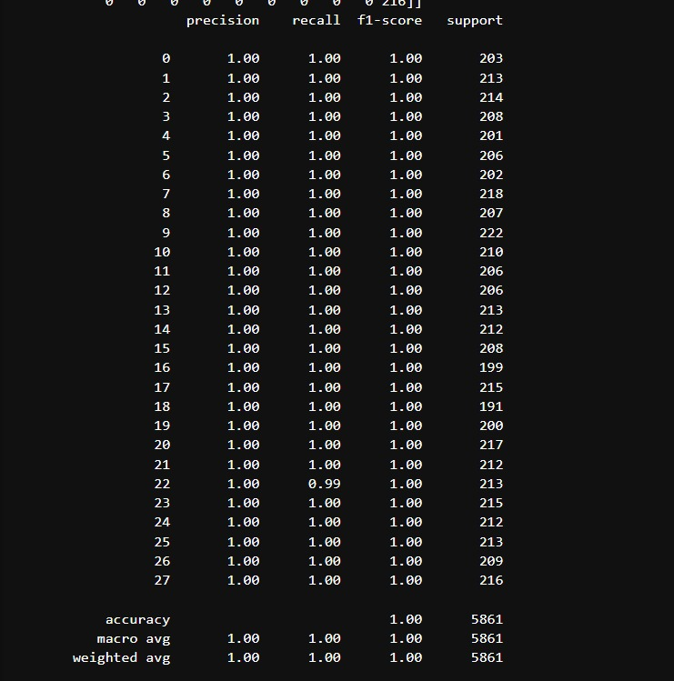
Figure 10Classification Report for CNN

Confusion Matrix
This is evidence of the testing and training confusion matrix, which shows how many times the algorithm made mistakes. It was found that the accuracy for each image was 100%. The area under the curve reached exactly (1,1). Training and Test results aligned perfectly on top of each other. But not L-shaped, which means it didn’t Immediately jump to (0,1), there could be data leakage, or task was too easy.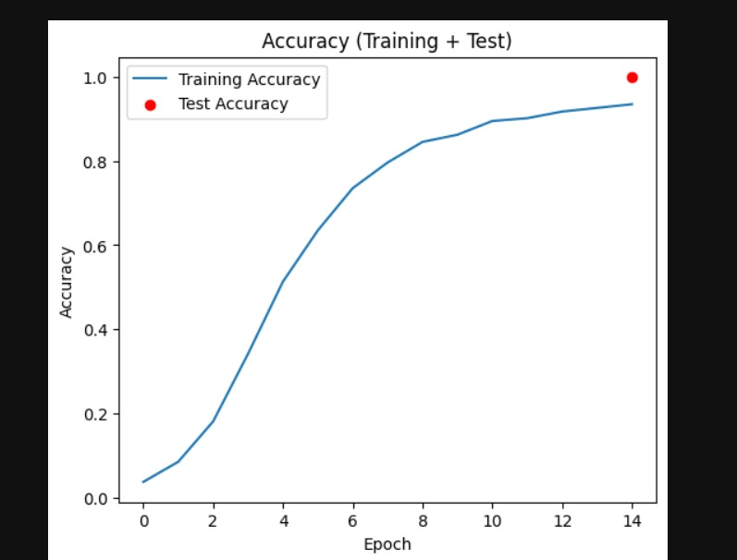
Figure 11Confusion Matrix for CNN

Roc_Curve Diagram
As shown below, each class's ROC curve hugs the top-left corner and the Area Under the Curve (AUC) = 1.0, which means:
- True Positive Rate (TPR) = 1.0
- False Positive Rate (FPR) = 0.0
- No overlap between classes (no missclassifications).

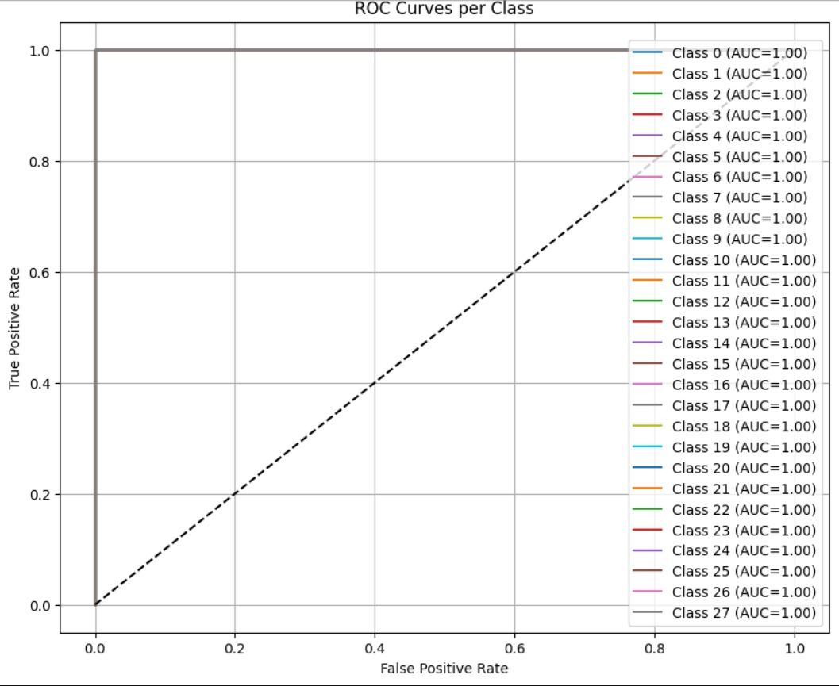
Figure 12Roc_Curve Diagram for CNN

SVM Results
After above 5 hours of training still the model got accuracy 50% which is a very low rate of result test, and comparing to CNN results below. It didn’t handle the dataset well due to it’s size, as seen here the test result is 50%, very low, machine didn’t learn well.

Confusion Matrix
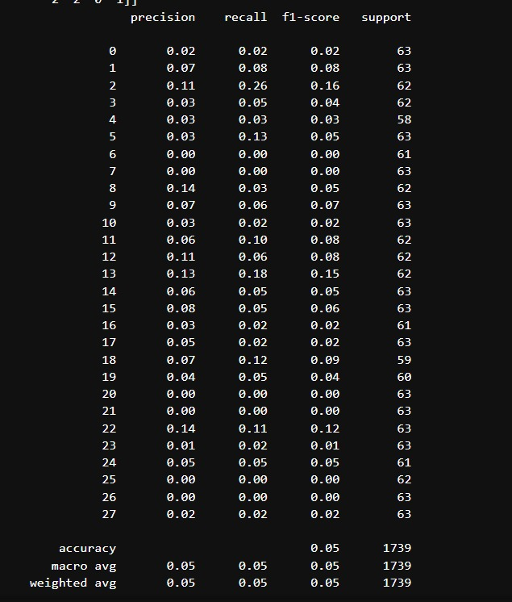
Figure 13Classificatio Report for SVM

Confusion Matrix
This is evidence of the testing and training confusion matrix, which shows how many times the algorithm made mistakes. It was found that the accuracy for each image was almost 0%. The area under the curve is almost 0. Which means there could be overfitting, or misclassification.
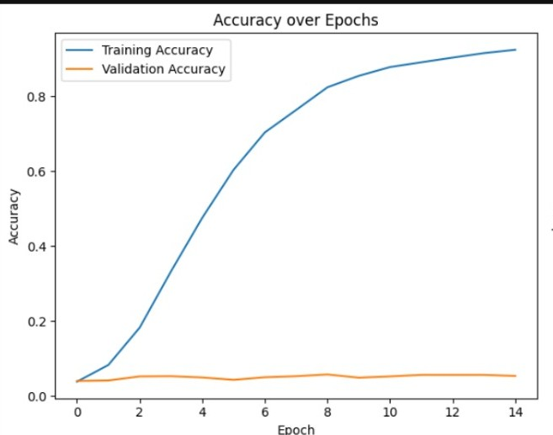
Figure 14 Confusion Matrix for SVM

Roc_Curve
As shown below, most class's ROC curve are not aligned, that means model not confidently separating positive from negative cases. This can be caused by class imbalance, confusing features, or insufficient data. Improvements can be made by augmenting data,
- Low True Positive Rate(TPR)
- High False Positive Rate (FPR)
- AUC near 0.5 = the model is guessing.

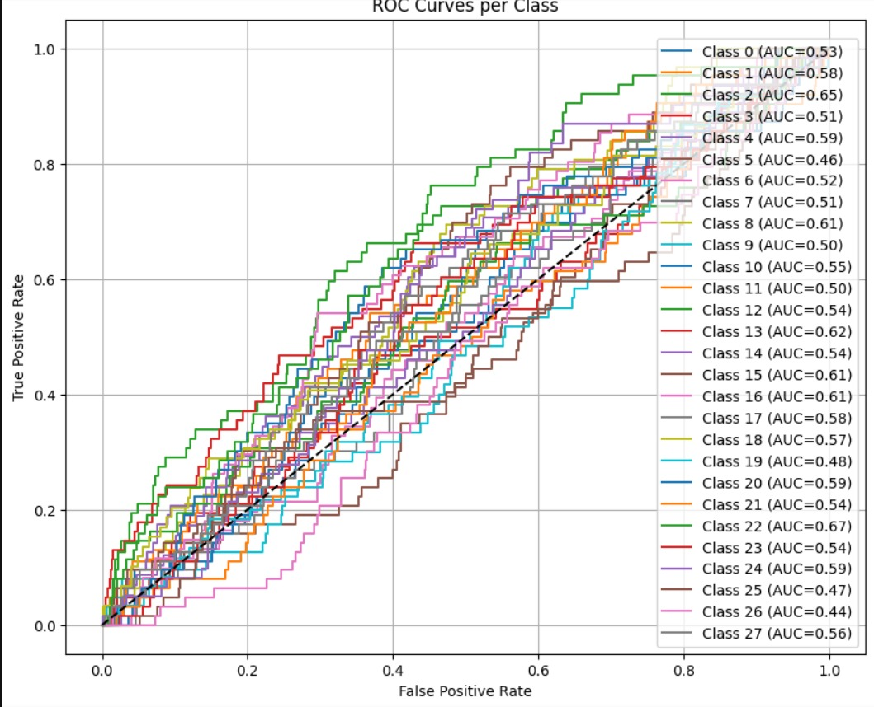
Figure 15Roc_Curve Diagram for SVM

Comparison Summary between SVM and CNN Results and Conclusion.

Comparison | SVM | CNN
Time training | Above 5 hours | Maximum 4 and half hours
Accuracy Results | 50% | 100%
Robustness | May struggle with variation | Generalize better to new unseen data.
Figure 16Comparison between SVM and CNN
In our comparison, the CNN significantly outperformed the SVM in terms of accuracy and ability to handle visual complexity, and data size.

Challenges
- The tools and environment differed from the python version that we had, it required Python 3.8 or 3.9, or python(tf_env). Which needed kernel changes.
- SVM algorithm took many hours and was very slow, which lead to find out the problems:
- High dimensionality (12,288 features).
- Large dataset size (if you have hundreds/thousands of images).
- SVM with RBF kernel scales poorly with dataset size (training time is at least quadratic in number of samples).
- No feature reduction (everything is raw pixels).

References
(Wirth, 2023)
(Hasasneh, 2020)
(Advantages of Support Vector Machines (SVM), n.d.)
(What is CNN, n.d.)
(kaggle, n.d.)

